Cell Differentiation and Epigenetics

Your body developed from a single cell, a fertilized egg. Repeated cell division produced the trillions of genetically identical cells in your body. Obviously, your body is not just one big blob of trillions of the same type of cell. Cell differentiation is the process that converted undifferentiated cells to the many different types of specialized cells in your body.
1. Give a brief description of the function of each type of cell shown in this figure. | 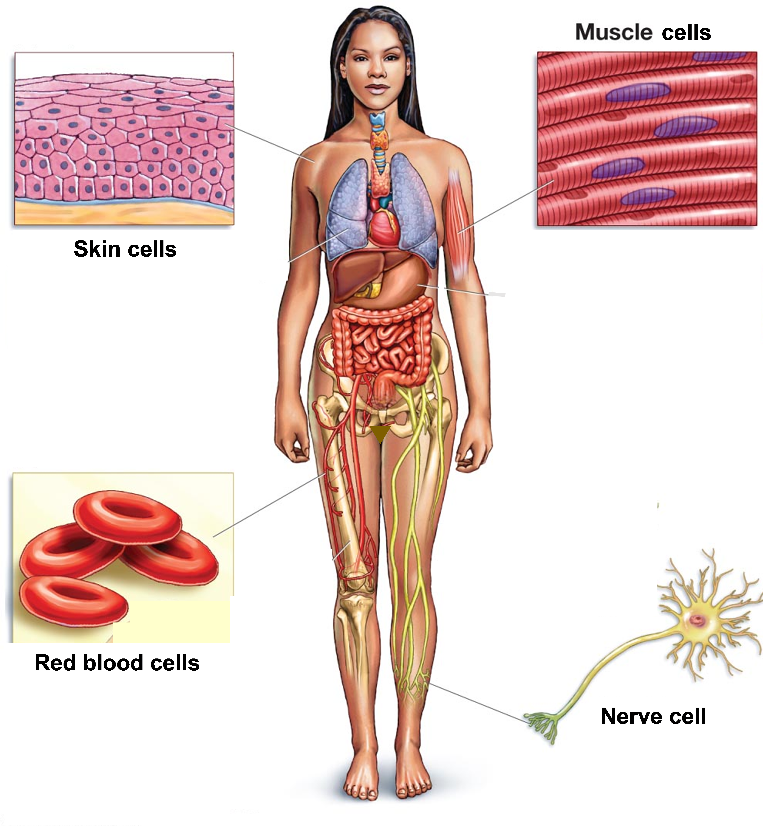
Different types of cells have different types of proteins. For example, red blood cells have lots of hemoglobin to carry oxygen, while skin cells have lots of keratin which helps to make the skin waterproof and strong.

Since the cells in your body were produced by mitosis, each cell has a complete set of genes. However, in each type of cell, some genes are turned on for protein production, and other genes are turned off. Cell differentiation depends on changes in which genes are turned on. Changes in which genes are turned on for protein production are called changes in gene expression.

2a. Which genes are present in the DNA of each type of cell shown here? In each type of cell, write the letters of each gene that is present.  H = gene that gives the instructions to make hemoglobin  K = gene that gives the instructions to make keratin | Cell that is differentiating to become a:
 | red blood cell | skin cell

2b. In each type of cell, put an * next to the letter of the gene that you would expect to be turned on for protein production.

A gene provides the instructions to make a protein by a two-step process.

3. First, transcription of a gene in the DNA produces

messenger RNA, which is abbreviated as __________.

Then, translation of the mRNA molecule produces

___________________.

We will analyze two ways that cells regulate transcription to control gene expression.

To begin transcription of a gene, several proteins must bind to the DNA. Transcription of a gene can be turned off by adding methyl groups (CH₃) to the DNA, so the proteins needed for transcription cannot bind to the DNA. When the methyl groups are removed, transcription can begin.

4a. In a cell that is differentiating to become a red blood cell, which gene would have methyl groups removed? hemoglobin gene ____ keratin gene ____

4b. Explain your reasoning.

Inside the cell, each very long DNA molecule is wound around histone proteins. Transcription of a gene can be turned on by adding acetyl groups (CH₃CO-) to the adjacent histones. The acetyl groups decrease the attraction between the histones and DNA, so the DNA is wound less tightly. This allows the proteins that begin transcription to bind to the DNA.

5a. During differentiation of red blood cells, what change would you expect in the number of acetyl groups on the histones next to the hemoglobin gene?
decrease ____ increase ____

5b. Explain your reasoning.

Epigenetic change is a general term that includes the addition or removal of methyl groups from the DNA of a gene and the addition or removal of acetyl groups from histones. Epigenetic changes modify the DNA or histones in ways that can have long-lasting effects on gene expression.

6. In the figures on this page, circle each arrow that represents an epigenetic change.
Epigenetic changes play a major role in the differentiation of different types of cells. Environmental exposures during development can influence these epigenetic changes.

7. In one experiment, some pregnant mice breathed polluted air while other pregnant mothers breathed unpolluted air. The offspring of the mice who breathed polluted air during pregnancy:
- gained weight faster, weighed more and had more fat when two months old
- had more transcription of a gene for a protein that stimulates development of fat cells
- had less methylation of this gene.
Complete this flowchart to show the causal sequence suggested by these results.

Environmental Exposure |  | Mother breathed polluted air during pregnancy.
↓ |  | ↓
Epigenetic Change in Offspring
↓ |  | ↓
Change in Gene Expression
↓ |  | ↓
Change in Offspring’s Characteristics

You have been learning about cell differentiation during development. Even after you are fully grown, your body still needs cell division and differentiation to replace cells that have died.

The main type of cells in the skin are called keratinocytes because keratin is the main protein produced by these cells and “cyte” stands for cell. Keratin provides structural strength for the skin and helps to make the skin waterproof. Every day throughout our lives, dead keratinocytes flake off the surface of our skin and the dead keratinocytes are replaced by mitosis and cell differentiation in the skin.

8. The sentences below describe the life and death of keratinocytes. Put the letter for each sentence next to the appropriate label or labels in the figure.
- Each keratinocyte only lives for a few weeks before it dies.
- Replacement cells are produced by mitosis of undifferentiated cells in the basal layer.
- These new cells differentiate as they move toward the surface of the skin.
- During differentiation, epigenetic changes result in increased transcription of the gene for keratin, which results in increased production of keratin.

By Dr. Ingrid Waldron, Dept Biology, Univ Pennsylvania, © 2017. This Student Handout and Teacher Notes (with learning goals, instructional suggestions, and background biology) are available at http://serendipstudio.org/exchange/bioactivities/epigenetics.

